**Login & Registration**

<EditText  
 android:id="@+id/etEmail"  
 android:layout_width="match_parent"  
 android:layout_height="wrap_content"  
 android:hint="Email"  
 android:inputType="textEmailAddress" />  
  
<EditText  
 android:id="@+id/etPassword"  
 android:layout_width="match_parent"  
 android:layout_height="wrap_content"  
 android:hint="Password"  
 android:inputType="textPassword" />  
  
<Button  
 android:id="@+id/btnLogin"  
 android:layout_width="wrap_content"  
 android:layout_height="wrap_content"  
 android:text="Login" />  
  
<TextView  
 android:id="@+id/tvRegister"  
 android:layout_width="wrap_content"  
 android:layout_height="wrap_content"  
 android:text="Don't have an account? Register"  
 android:layout_gravity="center_horizontal"  
 android:layout_marginTop="16dp"/>  
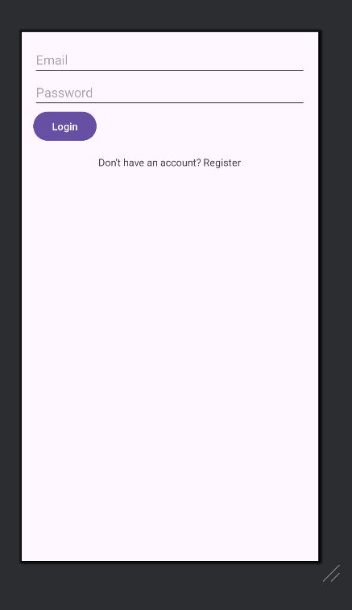

<?xml version="1.0" encoding="utf-8"?>  
<LinearLayout xmlns:android="http://schemas.android.com/apk/res/android"  
 android:layout_width="match_parent"  
 android:layout_height="match_parent"  
 android:orientation="vertical"  
 android:padding="16dp">  
  
 <EditText  
 android:id="@+id/etName"  
 android:layout_width="match_parent"  
 android:layout_height="wrap_content"  
 android:hint="Name" />  
  
 <EditText  
 android:id="@+id/etEmail"  
 android:layout_width="match_parent"  
 android:layout_height="wrap_content"  
 android:hint="Email"  
 android:inputType="textEmailAddress" />  
  
 <EditText  
 android:id="@+id/etPassword"  
 android:layout_width="match_parent"  
 android:layout_height="wrap_content"  
 android:hint="Password"  
 android:inputType="textPassword" />  
  
 <EditText  
 android:id="@+id/etConfirmPassword"  
 android:layout_width="match_parent"  
 android:layout_height="wrap_content"  
 android:hint="Confirm Password"  
 android:inputType="textPassword" />  
  
 <Button  
 android:id="@+id/btnRegister"  
 android:layout_width="wrap_content"  
 android:layout_height="wrap_content"  
 android:text="Register" />  
  
 <TextView  
 android:id="@+id/tvLogin"  
 android:layout_width="wrap_content"  
 android:layout_height="wrap_content"  
 android:text="Already have an account? Login"  
 android:layout_gravity="center_horizontal"  
 android:layout_marginTop="16dp"/>  
  
</LinearLayout>

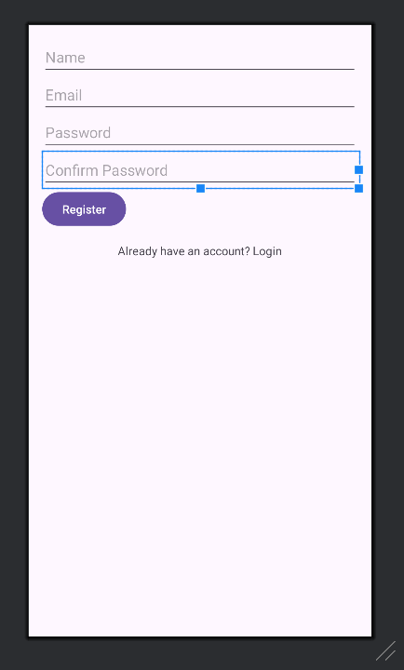

**Dashboard**

<TextView  
 android:layout_width="wrap_content"  
 android:layout_height="wrap_content"  
 android:text="Welcome to Dashboard"  
 android:textSize="20sp" />  
  
<Button  
 android:id="@+id/btnMyBadges"  
 android:layout_width="match_parent"  
 android:layout_height="wrap_content"  
 android:text="My Badges" />  
  
<Button  
 android:id="@+id/btnCertifications"  
 android:layout_width="match_parent"  
 android:layout_height="wrap_content"  
 android:text="Certifications" />  
  
<Button  
 android:id="@+id/btnShareAchievements"  
 android:layout_width="match_parent"  
 android:layout_height="wrap_content"  
 android:text="Share Achievements" />  
  
<TextView  
 android:id="@+id/tvProfile"  
 android:layout_width="wrap_content"  
 android:layout_height="wrap_content"  
 android:text="View Profile"  
 android:layout_gravity="center_horizontal"  
 android:layout_marginTop="16dp"/>  
  
<Button  
 android:id="@+id/btnSettings"  
 android:layout_width="match_parent"  
 android:layout_height="wrap_content"  
 android:text="Settings" />  
  
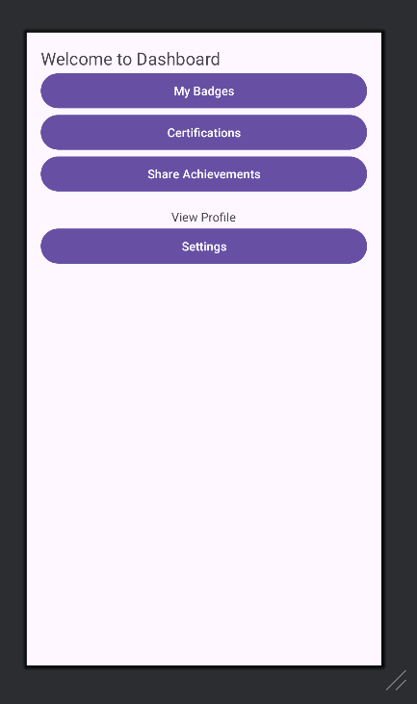

**Profile Page**

<ImageView  
 android:id="@+id/profilePic"  
 android:layout_width="100dp"  
 android:layout_height="100dp"  
 android:src="@drawable/default_profile_pic"  
 android:contentDescription="Profile Picture" />  
  
<TextView  
 android:id="@+id/profileName"  
 android:layout_width="wrap_content"  
 android:layout_height="wrap_content"  
 android:textSize="18sp"  
 android:text="User Name" />  
  
<TextView  
 android:id="@+id/profileEmail"  
 android:layout_width="wrap_content"  
 android:layout_height="wrap_content"  
 android:textSize="16sp"  
 android:text="user@example.com" />  
  
<TextView  
 android:layout_width="wrap_content"  
 android:layout_height="wrap_content"  
 android:textSize="16sp"  
 android:text="Earned Badges:"  
 android:layout_marginTop="16dp"/>  
  
<androidx.recyclerview.widget.RecyclerView  
 android:id="@+id/badgesRecyclerView"  
 android:layout_width="match_parent"  
 android:layout_height="wrap_content"  
 android:layout_marginTop="8dp"/>  
  
<TextView  
 android:layout_width="wrap_content"  
 android:layout_height="wrap_content"  
 android:textSize="16sp"  
 android:text="Certification Progress:"  
 android:layout_marginTop="16dp"/>  
  
<androidx.recyclerview.widget.RecyclerView  
 android:id="@+id/certificationsRecyclerView"  
 android:layout_width="match_parent"  
 android:layout_height="wrap_content"  
 android:layout_marginTop="8dp"/>  
  
<Button  
 android:id="@+id/btnEditProfile"  
 android:layout_width="wrap_content"  
 android:layout_height="wrap_content"  
 android:text="Edit Profile"  
 android:layout_gravity="center_horizontal"  
 android:layout_marginTop="16dp"/>  
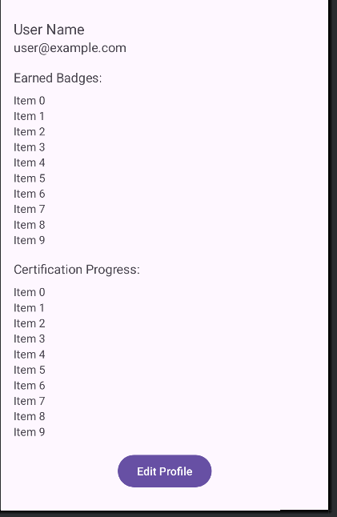

**Badge Listing**

<androidx.recyclerview.widget.RecyclerView xmlns:android="[http://schemas.android.com/apk/res/android"](http://schemas.android.com/apk/res/android%22) android:id="@+id/recyclerViewBadges" android:layout_width="match_parent" android:layout_height="match_parent" />

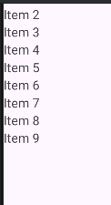

<?xml version="1.0" encoding="utf-8"?>  
<LinearLayout xmlns:android="http://schemas.android.com/apk/res/android"  
 android:layout_width="match_parent"  
 android:layout_height="wrap_content"  
 android:orientation="vertical"  
 android:padding="8dp"  
 android:layout_margin="8dp"  
 android:background="#F0F0F0">  
  
 <ImageView  
 android:id="@+id/badgeImage"  
 android:layout_width="80dp"  
 android:layout_height="80dp"  
 android:src="@drawable/default_badge_image"  
 android:layout_gravity="center_horizontal"  
 android:contentDescription="Badge Image" />  
  
 <TextView  
 android:id="@+id/badgeName"  
 android:layout_width="wrap_content"  
 android:layout_height="wrap_content"  
 android:text="Badge Name"  
 android:textSize="16sp"  
 android:layout_gravity="center_horizontal"  
 android:gravity="center"/>  
  
</LinearLayout>

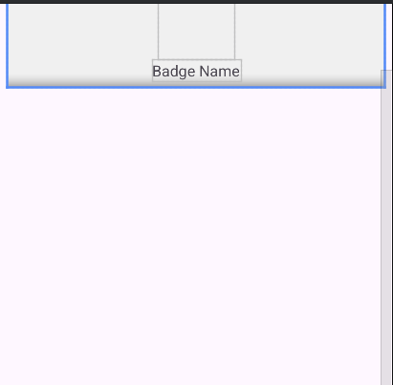

**Badge Details**

<?xml version="1.0" encoding="utf-8"?>  
<LinearLayout xmlns:android="http://schemas.android.com/apk/res/android"  
 android:layout_width="match_parent"  
 android:layout_height="match_parent"  
 android:orientation="vertical"  
 android:padding="16dp">  
  
 <ImageView  
 android:id="@+id/badgeImage"  
 android:layout_width="100dp"  
 android:layout_height="100dp"  
 android:src="@drawable/default_badge_image"  
 android:contentDescription="Badge Image" />  
  
 <TextView  
 android:id="@+id/badgeName"  
 android:layout_width="wrap_content"  
 android:layout_height="wrap_content"  
 android:textSize="18sp"  
 android:text="Badge Name" />  
  
 <TextView  
 android:id="@+id/badgeDescription"  
 android:layout_width="wrap_content"  
 android:layout_height="wrap_content"  
 android:textSize="16sp"  
 android:text="Badge Description" />  
  
 <TextView  
 android:id="@+id/badgeCriteria"  
 android:layout_width="wrap_content"  
 android:layout_height="wrap_content"  
 android:textSize="14sp"  
 android:text="Badge Criteria"  
 android:layout_marginTop="8dp"/>  
  
 <Button  
 android:id="@+id/btnShareBadge"  
 android:layout_width="wrap_content"  
 android:layout_height="wrap_content"  
 android:text="Share"  
 android:layout_marginTop="16dp"/>  
  
</LinearLayout>

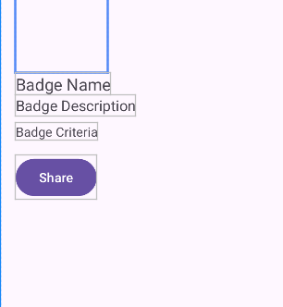

**Certification Progress**

<?xml version="1.0" encoding="utf-8"?>  
<LinearLayout xmlns:android="http://schemas.android.com/apk/res/android"  
 android:layout_width="match_parent"  
 android:layout_height="match_parent"  
 android:orientation="vertical"  
 android:padding="16dp">  
  
 <TextView  
 android:layout_width="wrap_content"  
 android:layout_height="wrap_content"  
 android:text="Certification Progress"  
 android:textSize="20sp" />  
  
 <ProgressBar  
 android:id="@+id/certificationProgressBar"  
 style="?android:attr/progressBarStyleHorizontal"  
 android:layout_width="match_parent"  
 android:layout_height="wrap_content"  
 android:layout_marginTop="8dp" />  
  
 <TextView  
 android:id="@+id/progressText"  
 android:layout_width="wrap_content"  
 android:layout_height="wrap_content"  
 android:text="0%"  
 android:layout_gravity="end" />  
  
 <androidx.recyclerview.widget.RecyclerView  
 android:id="@+id/tasksRecyclerView"  
 android:layout_width="match_parent"  
 android:layout_height="wrap_content"  
 android:layout_marginTop="16dp" />  
  
</LinearLayout>

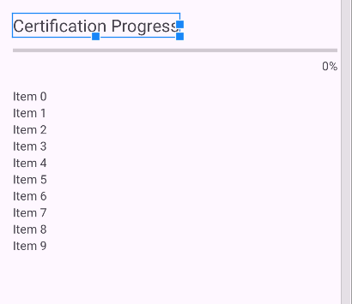

<?xml version="1.0" encoding="utf-8"?>  
<LinearLayout xmlns:android="http://schemas.android.com/apk/res/android"  
 android:layout_width="match_parent"  
 android:layout_height="wrap_content"  
 android:orientation="horizontal"  
 android:padding="12dp"  
 android:gravity="center_vertical">  
  
 <ImageView  
 android:id="@+id/taskIcon"  
 android:layout_width="wrap_content"  
 android:layout_height="wrap_content"  
 android:src="@drawable/ic_task_default"  
 android:layout_marginEnd="8dp"/>  
  
 <TextView  
 android:id="@+id/taskName"  
 android:layout_width="0dp"  
 android:layout_weight="1"  
 android:layout_height="wrap_content"  
 android:text="Task Name"  
 android:textSize="16sp" />  
  
 <TextView  
 android:id="@+id/taskStatus"  
 android:layout_width="wrap_content"  
 android:layout_height="wrap_content"  
 android:text="Status"  
 android:textSize="14sp" />  
  
</LinearLayout>

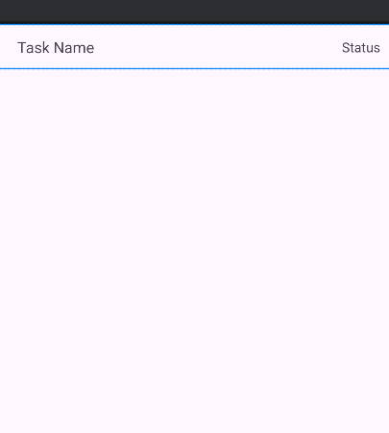

**Share Achievements**

<?xml version="1.0" encoding="utf-8"?>  
<LinearLayout xmlns:android="http://schemas.android.com/apk/res/android"  
 android:layout_width="match_parent"  
 android:layout_height="match_parent"  
 android:orientation="vertical"  
 android:padding="16dp">  
  
 <TextView  
 android:layout_width="wrap_content"  
 android:layout_height="wrap_content"  
 android:text="Share Achievement"  
 android:textSize="20sp" />  
  
 <ImageView  
 android:id="@+id/achievementImage"  
 android:layout_width="150dp"  
 android:layout_height="150dp"  
 android:src="@drawable/default_achievement_image"  
 android:layout_gravity="center_horizontal"  
 android:layout_marginTop="16dp"/>  
  
 <EditText  
 android:id="@+id/shareMessage"  
 android:layout_width="match_parent"  
 android:layout_height="wrap_content"  
 android:hint="Enter your sharing message"  
 android:layout_marginTop="16dp"/>  
  
 <Button  
 android:id="@+id/btnGenerateLink"  
 android:layout_width="match_parent"  
 android:layout_height="wrap_content"  
 android:text="Generate Shareable Link"  
 android:layout_marginTop="16dp"/>  
  
 <Button  
 android:id="@+id/btnShareLinkedIn"  
 android:layout_width="match_parent"  
 android:layout_height="wrap_content"  
 android:text="Share on LinkedIn"  
 android:layout_marginTop="8dp"/>  
  
 <Button  
 android:id="@+id/btnDownloadCertificate"  
 android:layout_width="match_parent"  
 android:layout_height="wrap_content"  
 android:text="Download Certificate"  
 android:layout_marginTop="8dp"/>  
  
</LinearLayout>

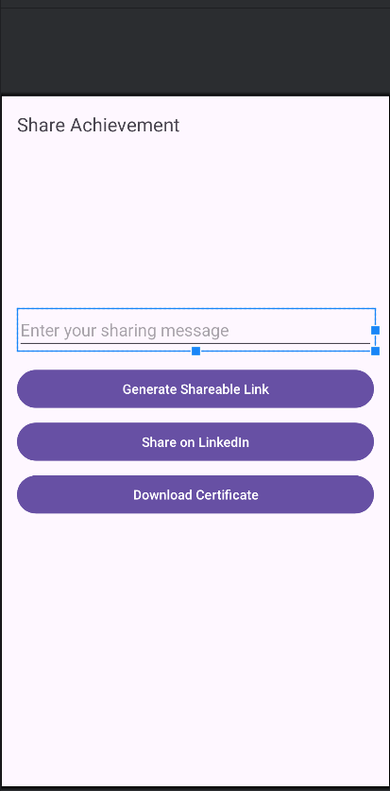

**Settings**

<?xml version="1.0" encoding="utf-8"?>  
<LinearLayout xmlns:android="http://schemas.android.com/apk/res/android"  
 android:layout_width="match_parent"  
 android:layout_height="match_parent"  
 android:orientation="vertical"  
 android:padding="16dp">  
  
 <TextView  
 android:layout_width="wrap_content"  
 android:layout_height="wrap_content"  
 android:text="Settings"  
 android:textSize="20sp" />  
  
 <Button  
 android:id="@+id/btnEditProfile"  
 android:layout_width="match_parent"  
 android:layout_height="wrap_content"  
 android:text="Edit Profile"  
 android:layout_marginTop="16dp"/>  
  
 <Button  
 android:id="@+id/btnChangePassword"  
 android:layout_width="match_parent"  
 android:layout_height="wrap_content"  
 android:text="Change Password"  
 android:layout_marginTop="8dp"/>  
  
 <Button  
 android:id="@+id/btnLogout"  
 android:layout_width="match_parent"  
 android:layout_height="wrap_content"  
 android:text="Logout"  
 android:layout_marginTop="8dp"/>  
  
</LinearLayout>

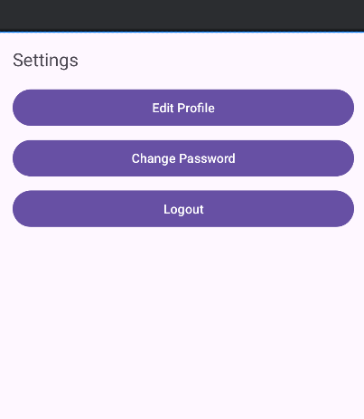

<?xml version="1.0" encoding="utf-8"?>  
<LinearLayout xmlns:android="http://schemas.android.com/apk/res/android"  
 android:layout_width="match_parent"  
 android:layout_height="match_parent"  
 android:orientation="vertical"  
 android:padding="16dp">  
  
 <TextView  
 android:layout_width="wrap_content"  
 android:layout_height="wrap_content"  
 android:text="Change Password"  
 android:textSize="20sp" />  
  
 <EditText  
 android:id="@+id/etOldPassword"  
 android:layout_width="match_parent"  
 android:layout_height="wrap_content"  
 android:hint="Old Password"  
 android:inputType="textPassword"  
 android:layout_marginTop="16dp"/>  
  
 <EditText  
 android:id="@+id/etNewPassword"  
 android:layout_width="match_parent"  
 android:layout_height="wrap_content"  
 android:hint="New Password"  
 android:inputType="textPassword"  
 android:layout_marginTop="8dp"/>  
  
 <EditText  
 android:id="@+id/etConfirmNewPassword"  
 android:layout_width="match_parent"  
 android:layout_height="wrap_content"  
 android:hint="Confirm New Password"  
 android:inputType="textPassword"  
 android:layout_marginTop="8dp"/>  
  
 <Button  
 android:id="@+id/btnSavePassword"  
 android:layout_width="wrap_content"  
 android:layout_height="wrap_content"  
 android:text="Save Password"  
 android:layout_marginTop="16dp"/>  
  
</LinearLayout>

